Always use the python virtual environment for every project.
Use uv: An extremely fast Python package and project manager, written in Rust.
- A single tool to replace pip, pip-tools, pipx, poetry, pyenv, twine, virtualenv, and more.
- 10-100x faster than pip.
- Provides comprehensive project management, with a universal lockfile.
Define API key in separate file usually in .env file
Groq can be used for free API Keys for many LLMs.

Using Python , more token are burnt in using Gemini as compared to Java script.

Use python-dotenv library for managing "secrets" like API keys, database passwords, and configuration settings.it reads key-value pairs from a .env file and adds them to your system's environment variables.
Initialize a model
The easiest way to get started with a standalone model in LangChain is to use init_chat_model to initialize one from a chat model provider of your choice.
Using init_chat_model
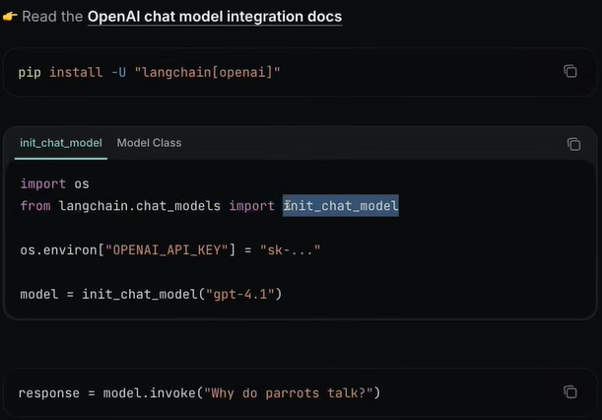
Using Model Class
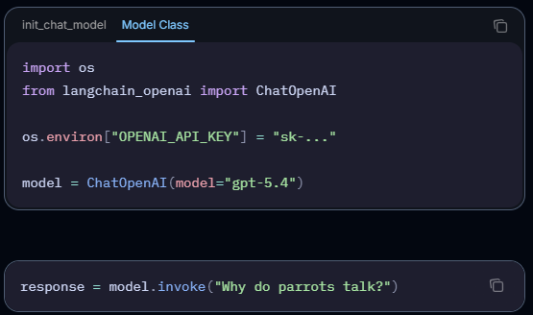

Model Classes require provider-specific imports (e.g., ChatOpenAI) and hardcode your application to a single LLM vendor.
init_chat_model is a unified factory function that lets you dynamically swap providers (OpenAI, Anthropic, etc.) using simple string arguments without changing your imports or code structure.
Recommendation: Use init_chat_model by default to keep your code flexible, future-proof, and decoupled from specific vendors.

QUESTION: How API keys are working without get os env method

